EV Battery Health Predictor using Machine Learning
Project Report — Module 1

1. Objective
This project trains a machine learning model to classify electric vehicle (EV) battery health into three categories — Healthy, Degrading, and Critical — using real-world lithium-ion battery cycling data. The model uses features derived from each charge/discharge cycle (voltage behavior, temperature, and cycle count) to predict the battery's condition, supporting predictive maintenance and early replacement planning.

2. Dataset
The NASA Prognostics Center of Excellence (PCoE) Li-ion Battery Dataset was used. It contains real charge, discharge, and impedance measurements collected from 18650 lithium-ion cells (rated capacity 2.0 Ah) cycled to failure at NASA Ames Research Center. Eleven battery units (B0005, B0006, B0007, B0018, B0049–B0051, B0053–B0056) contributed a combined 1,066 discharge cycles.

2.1 Cleaning Steps
- Removed rows with missing values and non-physical readings (e.g., capacity ≤ 0.3 Ah, temperature ≥ 100°C).
- Applied a rolling-median filter per battery to remove single-cycle sensor spikes (brief rig recalibration artifacts common in the raw NASA logs), while preserving the true degradation trend.
- Renumbered cycles per battery after cleaning and recomputed a robust per-battery baseline capacity (median of the first 3 clean cycles).
- Removed exact duplicate rows.
After cleaning, 972 of 1,066 cycles (91%) remained — a clean, well-balanced dataset.

2.2 Health Labeling Rule
Each cycle was labeled by remaining capacity as a percentage of that battery's own rated (baseline) capacity — a standard approach in EV battery management:
- Healthy: capacity ≥ 90% of rated capacity
- Degrading: 80%–90% of rated capacity
- Critical: below 80% of rated capacity

2.3 Class Balance
Healthy: 319 cycles | Degrading: 315 cycles | Critical: 338 cycles — a near-even three-way split, avoiding class-imbalance bias.

3. Exploratory Charts
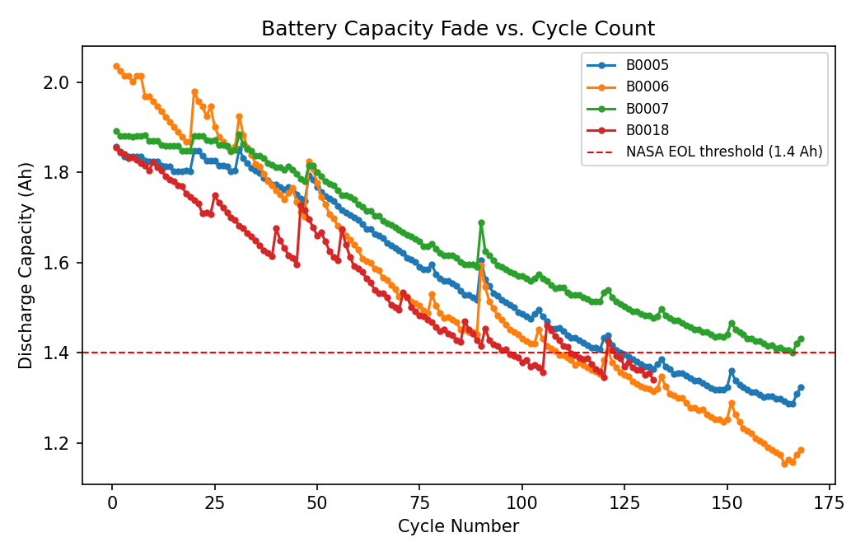
Figure 1. Discharge capacity fades steadily as cycle count increases, crossing NASA's 30% end-of-life threshold (1.4 Ah) around cycle 100–130 for most cells.
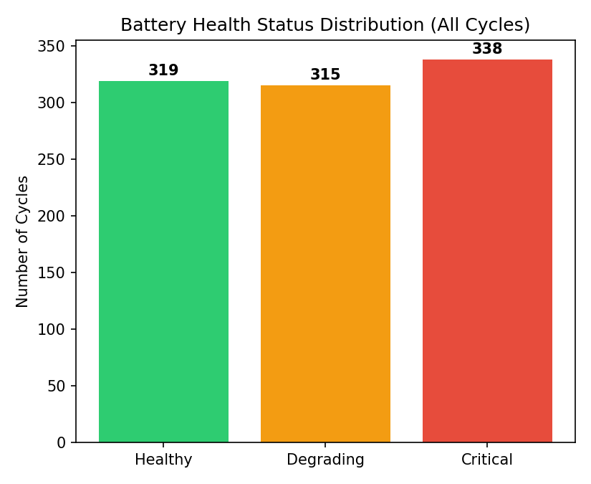
Figure 2. Distribution of battery health labels across all cleaned cycles.

4. Model & Methodology
A Random Forest classifier (300 trees, max depth 8, balanced class weights) was trained using scikit-learn on 8 engineered features per cycle: discharge time to peak temperature, max discharge temperature, discharge temperature rise rate, discharge time below 3V, discharge voltage slope, charge time to peak temperature, max charge temperature, and cycle number. Features were standardized, and the data was split 75/25 into training and test sets (stratified by class).

5. Results

5.1 Accuracy
Overall test accuracy: 88.9% (216 of 243 test cycles correctly classified).

5.2 Confusion Matrix
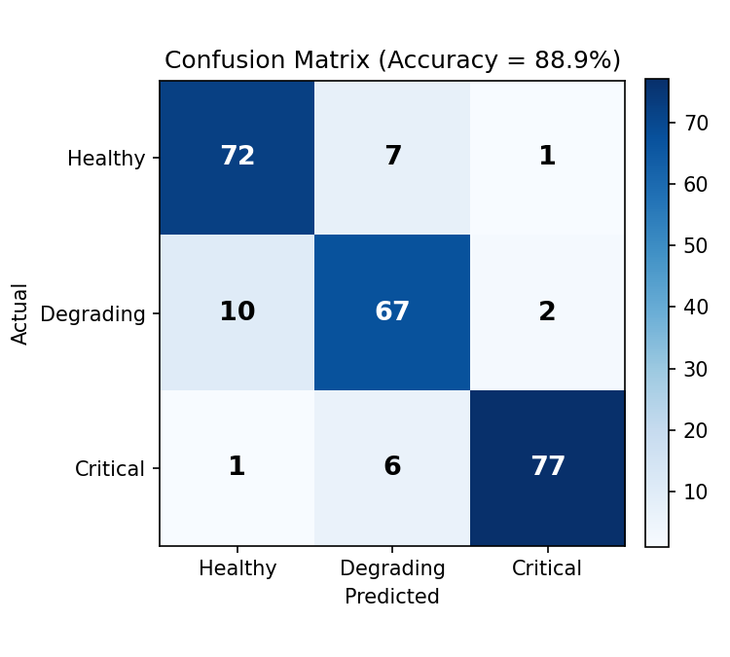
Figure 3. Confusion matrix on the held-out test set.

5.3 Per-Class Performance
Class | Precision | Recall | F1-score | Support
Healthy | 0.87 | 0.90 | 0.88 | 80
Degrading | 0.84 | 0.85 | 0.84 | 79
Critical | 0.96 | 0.92 | 0.94 | 84
Accuracy |  |  | 0.89 | 243

The Critical class was predicted most reliably (96% precision, 92% recall) — the sharpest degradation signals are easiest to detect. The Degrading class, sitting between the other two, was hardest to separate (84% precision/recall), which is expected since its boundary conditions blend gradually into its neighbors.

5.4 Feature Importance
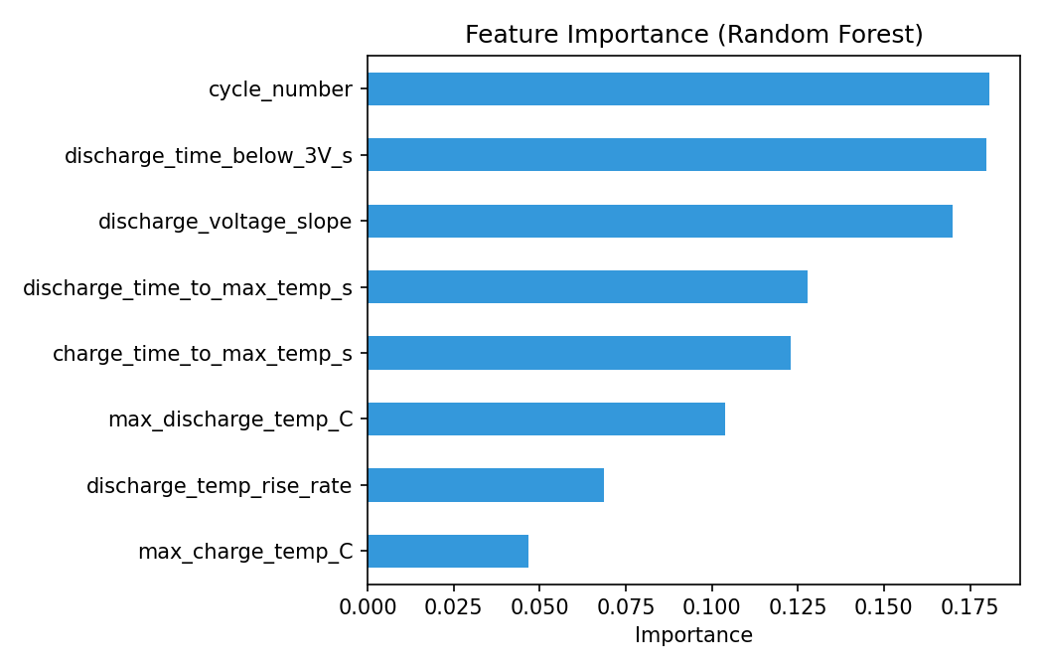
Figure 4. Relative importance of each feature in the trained Random Forest.
Feature | Importance
Cycle number | 0.181
Discharge time below 3V | 0.180
Discharge voltage slope | 0.170
Discharge time to max temp | 0.128
Charge time to max temp | 0.123
Max discharge temperature | 0.104
Discharge temp rise rate | 0.069
Max charge temperature | 0.047

Cycle number, discharge time below 3V, and discharge voltage slope were the three strongest predictors — consistent with battery physics, since aged cells discharge to the cutoff voltage faster and show steeper voltage drop-off.

6. Conclusion
The trained Random Forest model classifies EV battery health into Healthy, Degrading, and Critical categories with 88.9% accuracy using only cycle-level voltage and temperature features — no need for full raw discharge curves. This makes the approach practical for real-time battery management systems, where lightweight per-cycle summaries are more feasible to compute than full time-series signals.

6.1 Limitations & Future Work
- The dataset covers 11 cells of one chemistry/form factor (18650, 2.0 Ah); results may not generalize directly to other EV pack chemistries without retraining.
- The Degrading class would benefit from additional features (e.g., internal resistance trends, incremental capacity analysis) to sharpen the boundary with its neighbouring classes.
- Future work could explore deep learning (LSTM) on raw discharge curves, or extend the health target to Remaining Useful Life (RUL) regression.

7. Deliverables Summary
- Trained classification model — Random Forest (scikit-learn)
- Accuracy score and confusion matrix — 88.9% accuracy, see Section 5
- Charts — capacity vs. cycle count, health distribution, confusion matrix, feature importance
- This report

